**Number of bug:** #1

**Tittl:** at checkout screen, Postal Code Field Accepts Letters & Special Characters

**Steps_ description:** 1)open Website swage laps

2)login with standard_user account with password "secret_sauce".

3)choose item: Sauce Labs Bike Light

4)go to cart screen ,and click on checkout button

5) enter: Menna in first name field ,Ayman in last name field ,L in postal code field

**Screen shout or screen video:**

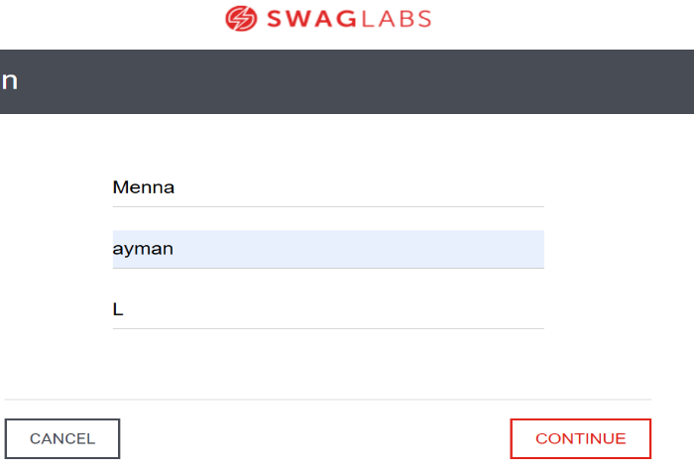

Result

* Expected: show error that postal code field didn’t accept character
* Actual: accept character at postal code field without error (cycle complet)

1. **Priority:** medium
2. **Severity:** medium

**Number of bug:** #2

**Tittl:** at checkout screen, don’t show label in text box when you enter any text

**Steps_ description:** 1)open Website swage laps

2)login with standard_user account with password "secret_sauce".

3)choose item: Sauce Labs Bike Light

4)go to cart screen ,and click on checkout button

5)click on continue

**Screen shout or screen video:**

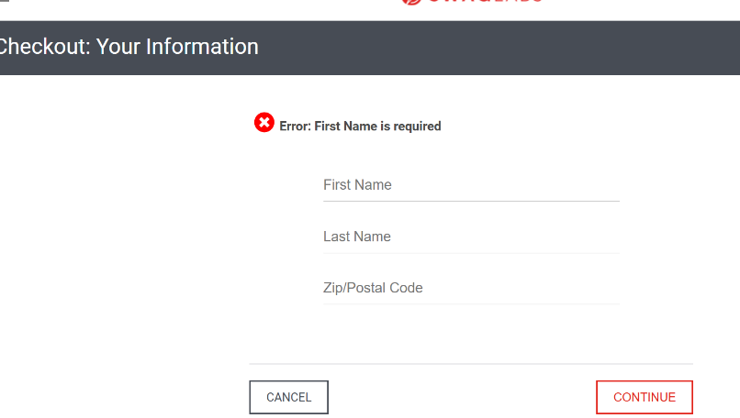

**Result**

* **Expected:** system is required to fill in all the data
* **Actual:** System should display an error message on all Component

**Priority:** medium

**Severity:** medium

**Number of bug:** #3

**Tittl:** at checkout screen, don’t show error handling when the checkout page is refreshed during payment

**Steps_ description:** 1)open Website swage laps

2)login with standard_user account with password "secret_sauce".

3)choose item: Sauce Labs Bike Light

4)go to cart screen ,and click on checkout button

5) enter: Mennasadddff fgfdfsawein first name field ,Aymandlkjlfjlkjjsdlkjdss in last name field 1233889309009483909 in postal code field

**Screen shout or screen video:**

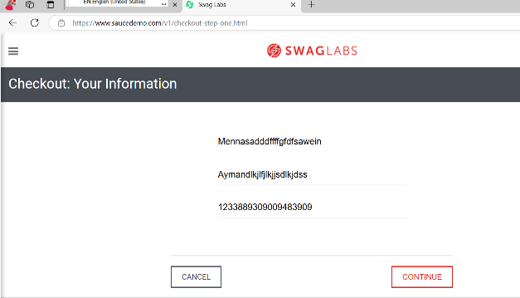

Result

* **Expected:** The system should trim input or show an error
* **Actual:** accept character at fields without error (cycle complet)

1. **Priority:** medium
2. **Severity:** medium

**Number of bug: #4**

**Tittl:** at checkout screen, user can edit cart after reaching the payment page

**Steps_ description**: 1)open Website swage laps

2)login with problem_user account with password "secret_sauce".

3)choose item: Sauce Labs Bike Light

4)go to cart screen ,and click on checkout button

5) enter: Menna in first name field ,Ayman in last name field ,L in postal code field

6) Click on continue button

7) click on checkout button

8) Navigate back and try to modify the cart

**Screen shout or screen video:**

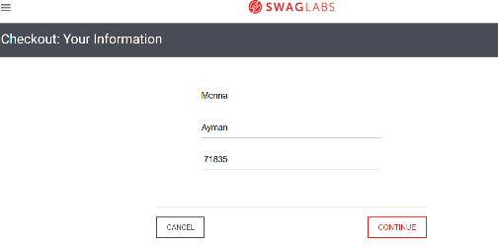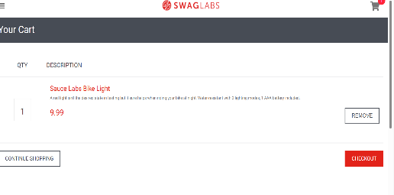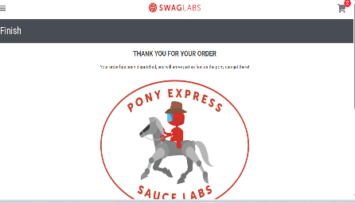

**Result**

* **Expected:** Cart should be locked at the payment stage
* **Actual:** accept go to cart to edit it without error (cycle complet**)**

1. **Priority:** medium
2. **Severity:** medium

**Number of bug:** #5

**Tittl:** at checkout screen, not correct total price for bulk purchases

**Steps_ description:** 1)open Website swage laps

2)login with problem_user account with password "secret_sauce".

3)choose items

4)go to cart screen ,and click on checkout button

5) enter: Menna in first name field ,Ayman in last name field ,71402 in postal code field

6) verify price calculation in checkout Price

**Screen shout or screen video:**

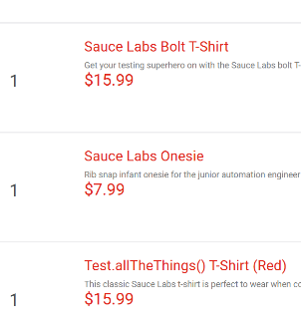 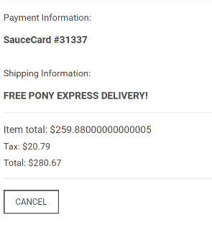

Result

* **Expected:** should match product unit price
* **Actual:** product unit price not match

**Priority:** high

**Severity:** high

**Number of bug:** #6

**Tittl:** at checkout screen, not correct TAX for bulk purchases

**Steps_ description:** 1)open Website swage laps

2)login with problem_user account with password "secret_sauce".

3)choose items

4)go to cart screen ,and click on checkout button

5) enter: Menna in first name field ,Ayman in last name field ,71303 in postal code field

6) .Verify tax calculations

**Screen shout or screen video:**

 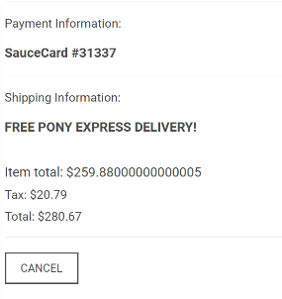

Result

* **Expected:** Tax should be correctly applied as per store policy
* **Actual:** tax not applied as per store policy

**Priority:** high

**Severity:** high

**Number of bug:** #7 **(** **Functional Bugs )**

**Tittl:** at checkout screen, Checkout Allows spaces and empty Fields

**Steps_ description:** 1)open Website swage laps

2)login with standard_user account with password "secret_sauce".

3)choose items

4)go to cart screen ,and click on checkout button

5)Menna in first name field ,Ayman in last name field ,71303 in postal code field

6) .Click "CONTINUE"

7)click on finish button

**Screen shout or screen video:**

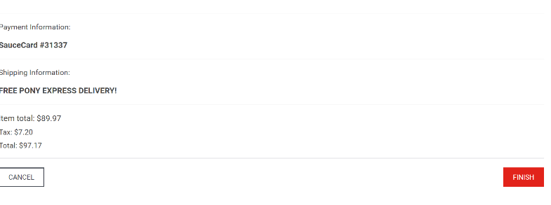 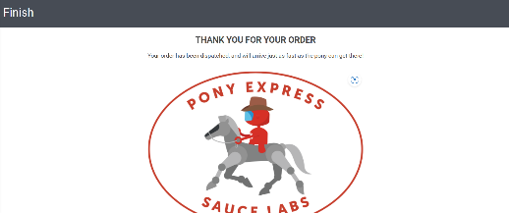

Result

* Expected: Display a clear "Order Successfully Placed" message and redirect to the homepage.
* Actual: there's no clear success message or redirection, in finish page

**Priority:** medium

**Severity:** low

**Number of bug:** #8 **(** **Functional Bugs )**

* **Tittl:** at checkout screen, The checkout form allows proceeding with some empty fields.

**Steps_ description:** 1)open Website swage laps

2)login with standard_user account with password "secret_sauce".

3)choose items

4)go to cart screen ,and click on checkout button

5)Leave the last name blank ,enter Ayman in first name field, enter 71835 in postal code field

6) .Click "CONTINUE"

**Screen shout or screen video:**

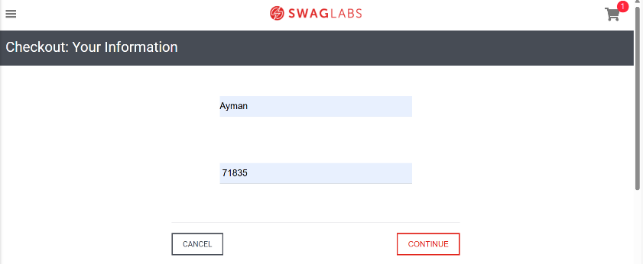 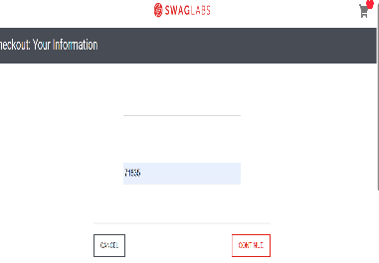

Result

* Expected: Should show validation errors for missing required fields
* Actual: The checkout form allows proceeding with some empty fields.

**Priority:** medium

**Severity:** low

**Number of bug:** #9 **(** **Functional Bugs )**

* **Tittl:** at checkout screen, When logged in as "problem_user", product images and checkout steps may not load correctly.

**Steps_ description:** 1)open Website swage laps

2) Login as "problem_user" with password "secret_sauce".

3)choose items, Some product images and buttons may be missing.

4)go to cart screen ,and click on checkout button

**Screen shout or screen video:**

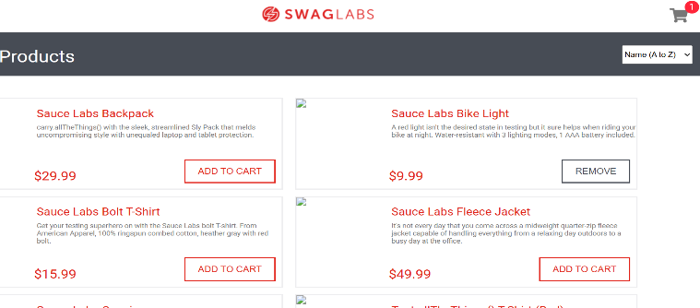 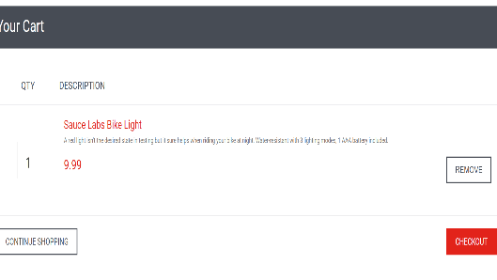

Result

* Expected: The UI should load correctly for all users
* Actual: Users may not be able to complete the checkout process

**Priority:** high

**Severity:** medium

**Number of bug:** #10

**Tittl:** If you add items, go to checkout, then remove all items, the checkout page still allows you to continue.

**Steps_ description:** 1)open Website swage laps

2)login with standard_user account with password "secret_sauce".

3)choose items

4)go to cart screen ,and click on checkout button

5)Menna in first name field ,Ayman in last name field ,71303 in postal code field

6) Remove all items from the cart.

7) .Click "CONTINUE"

8)click on finish button

**Screen shout or screen video:**

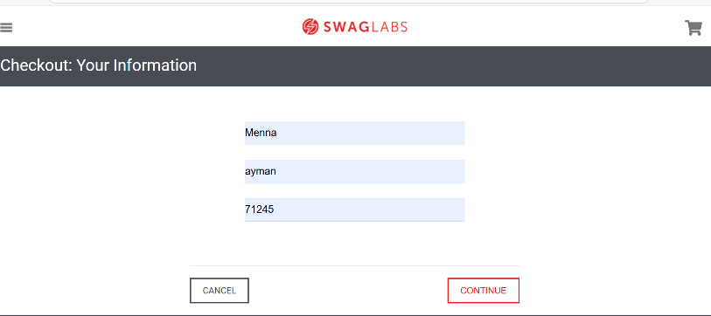 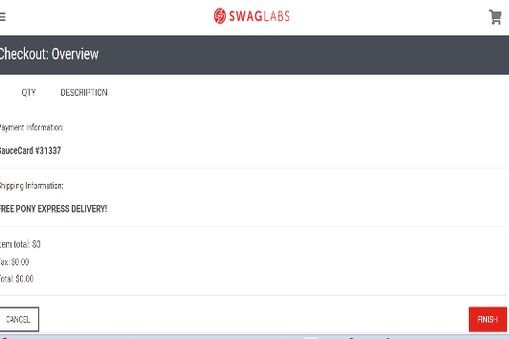

Result

* Expected: Checkout should not continue with an empty cart
* Actual: The system doesn’t block the action, even though the cart is empty

**Priority:** medium

**Severity:** low

**Number of bug:** #11( UI/UX Issues)

**Tittl:** The system skips payment selection—users are not asked how they want to pay.

**Steps_ description:** 1)open Website swage laps

2)login with standard_user account with password "secret_sauce".

3)choose items

4)go to cart screen ,and click on checkout button

5)Menna in first name field ,Ayman in last name field ,71303 in postal code field

6) Remove all items from the cart.

7) .Click "CONTINUE"

8) Proceed through checkout.

**Screen shout or screen video:**

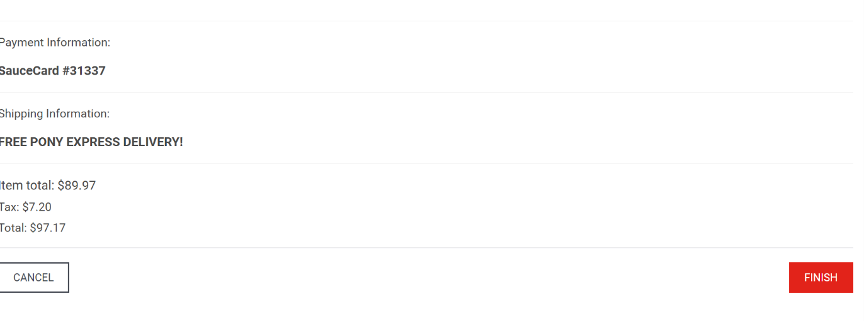

Result

* Expected: There should be a step where users select a payment method (Card, PayPal, etc.).
* Actual: there’s no option to choose a payment method

**Priority:** low

**Severity:** low

**Number of bug:** #12

* **Tittl:** After placing an order, clicking the **browser back button** allows the user to **resubmit the same order** multiple times.

**Steps_ description:** 1)open Website swage laps

2)login with problem_user account with password "secret_sauce".

3)choose items

4)go to cart screen ,and click on checkout button

5)Menna in first name field ,Ayman in last name field ,71303 in postal code field

6) .Click "CONTINUE"

7) click on finish button

8)click on back button and choose the same order

9) Click "Finish" again → The same order gets resubmitted.

**Screen shout or screen video:**

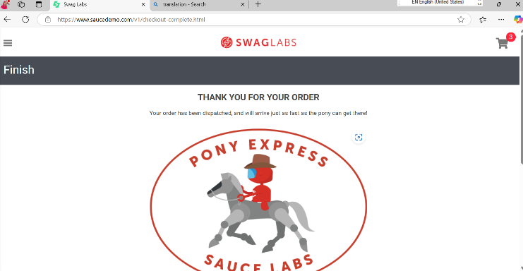 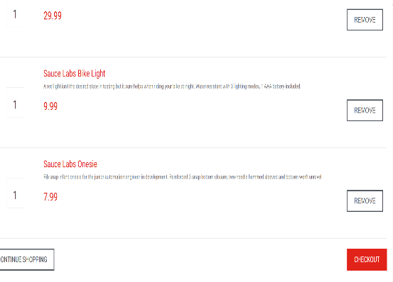

Result

* Expected: Users should **not be able to resubmit an order** once completed.
* Actual: Users may be **charged multiple times** for the same order.

**Priority:** **Critical**

**Severity:** medium

**Number of bug**: #13 **(Functional Bug)**

**Tittl:** The system **accepts a single letter** as a valid first or last name, **No Error for Short First or Last Names.**

**Steps_ description:** 1)open Website swage laps

2)login with standard_user account with password "secret_sauce".

3)choose items

4)go to cart screen ,and click on checkout button

5) Enter "J" as the first name, Enter "D" as the last name ,Enter 71303 in postal code field

6) . Click "CONTINUE"

**Screen shout or screen video:**

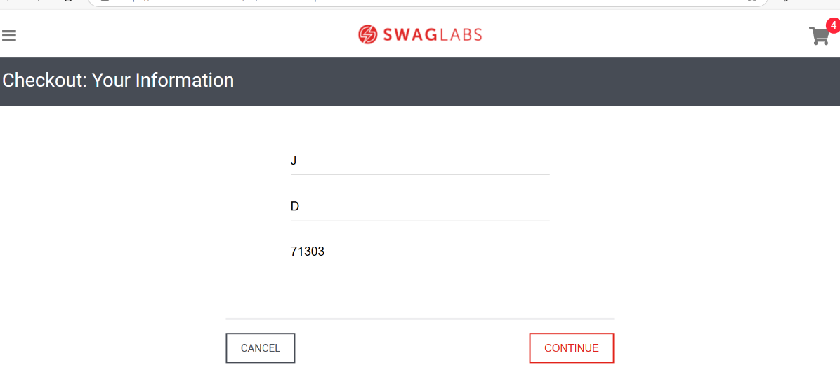

**Result**

* **Expected:** Name fields should **require at least 2 or 3 characters**.
* **Actual:** Unrealistic user data, potential fraud risk.

**Priority:** medium

**Severity:** low